Artificial Intelligence:
- Mimic human intelligence
- Perform task that do not need any human intelligence for performing task like problem solving, reasoning.
Machine Learning:
- System learn from the data to make the predictive decision without programming language.
Deep Learning:
- This is subfield of Ml, it uses artificial neural network in many layer to learn from the data. Where artificial neural network mimic human brain.
Neural Network:
- Mimic complex human intelligence
- Model consist interconnected node or neuron for processing the data, learn from the data and ready for decision making and solve complex question.
Large Language Model:
- Basically builded on the neural network by feeding immense amount of the data for generating nlp and give output natural language
- Advanced AI systems built on deep neural networks designed to process, understand and generate human-like text. By using massive datasets and billions of parameters
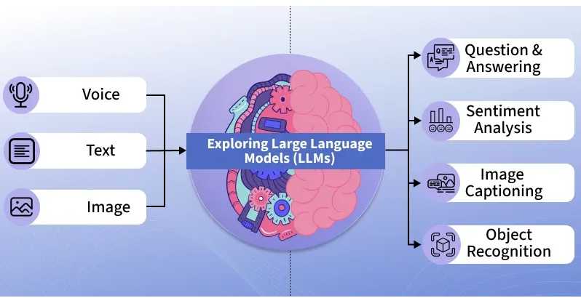

Real World Scenario:
- Insurance: it handle and processing the huge amount of data of the customer regarding their insurance type and personal detail covering amount of the insurance so by using AI we can easily determine for which of the customer fulfill all the condition for calming the insurance.

- Finance: It plays huge role In finance sector by collect data about recent market trends and all the attribute about that firm and can predict future result for the same firm to be invested or not. Managing user detail for the same.

- Chatbots: It plays Crucial role in chatbots in ai power chatbots by using Retrival Augmentation Generation remove hallucination from the response, give accurate relevant answer to the user

References:
- http://ibm.com/think/topics/artificial-intelligence
- https://www.geeksforgeeks.org/machine-learning/ai-ml-and-data-science-tutorial-learn-ai-ml-and-data-science/

